1-SQL GRANT

📌 What is GRANT?
# Source: AI Source: Provided by: [Data Path: Persons Table -> ID Column: 1, Name_En Column: Motasem Essam] -> From: [ChatGPT] on [6/11/2026]
The GRANT command is used to give privileges (permissions) to users so they can perform specific actions in a MySQL database, such as:
- Reading data (SELECT)
- Inserting or updating data (INSERT, UPDATE)
- Creating or deleting tables (CREATE, DROP)

🧠 Syntax
# Source: AI Source: Provided by: [Data Path: Persons Table -> ID Column: 1, Name_En Column: Motasem Essam] -> From: [ChatGPT] on [6/11/2026]
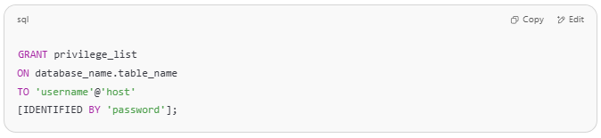
GRANT privilege_list
ON database_name.table_name
TO 'username'@'host'
[IDENTIFIED BY 'password'];

🔑 Common Privileges
# Source: AI Source: Provided by: [Data Path: Persons Table -> ID Column: 1, Name_En Column: Motasem Essam] -> From: [ChatGPT] on [6/11/2026]
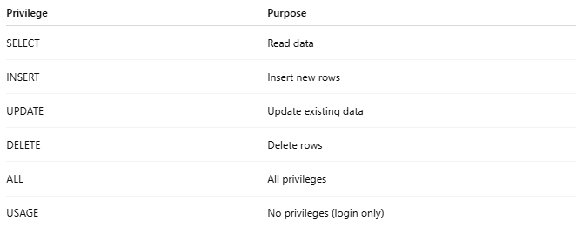
Privilege | Purpose
SELECT | Read data
INSERT | Insert new rows
UPDATE | Update existing data
DELETE | Delete rows
ALL | All privileges
USAGE | No privileges (login only)

✅ Basic Example
# Source: AI Source: Provided by: [Data Path: Persons Table -> ID Column: 1, Name_En Column: Motasem Essam] -> From: [ChatGPT] on [6/11/2026]
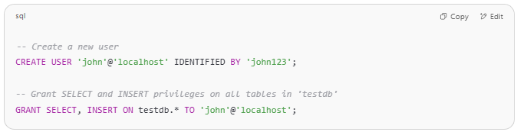
-- Create a new user
CREATE USER 'john'@'localhost' IDENTIFIED BY 'john123';

-- Grant SELECT and INSERT privileges on all tables in 'testdb'
GRANT SELECT, INSERT ON testdb.* TO 'john'@'localhost';

📌 This lets the user john read and insert data into any table in the testdb database.

🔐 Granting ALL Privileges
# Source: AI Source: Provided by: [Data Path: Persons Table -> ID Column: 1, Name_En Column: Motasem Essam] -> From: [ChatGPT] on [6/11/2026]
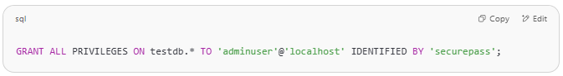
GRANT ALL PRIVILEGES ON testdb.* TO 'adminuser'@'localhost' IDENTIFIED BY 'securepass';

This gives full control over testdb.

If there are error in mysql
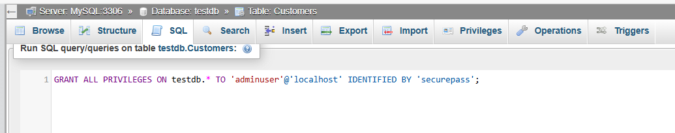
GRANT ALL PRIVILEGES ON testdb.* TO 'adminuser'@'localhost' IDENTIFIED BY 'securepass';
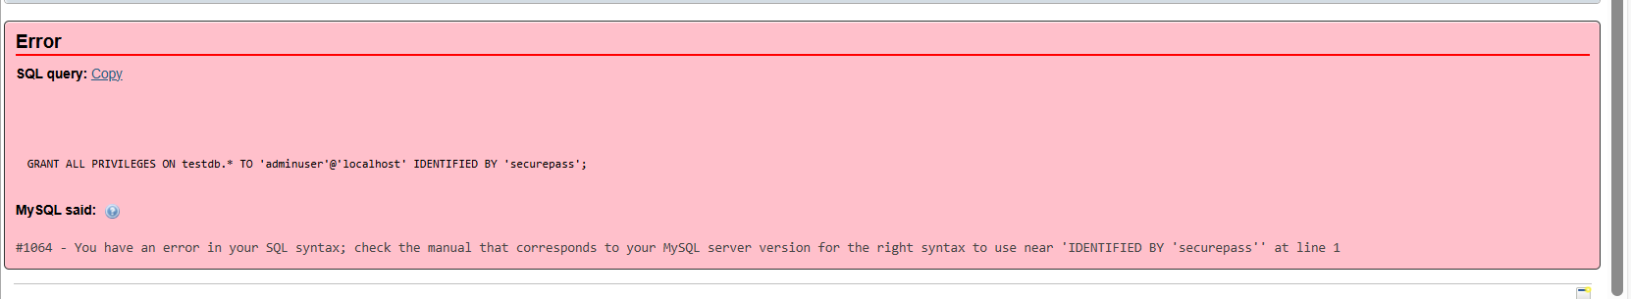
The error you’re seeing—
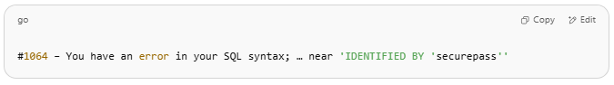
#1064 – You have an error in your SQL syntax; … near 'IDENTIFIED BY 'securepass''

—happens because modern MySQL (>= 8.0) no longer allows you to set a password in the same GRANT statement. You must create (or alter) the user separately, then grant privileges.

✅ Correct Sequence
- Create the user (with password)
- Grant privileges
- (Optional) Flush privileges—though not needed in modern MySQL
1. Create the user
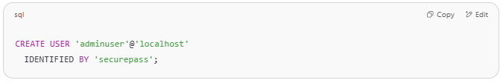
CREATE USER 'adminuser'@'localhost'
IDENTIFIED BY 'securepass';

2. Grant privileges
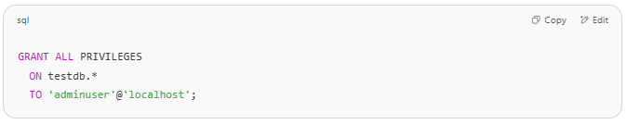
GRANT ALL PRIVILEGES
ON testdb.*
TO 'adminuser'@'localhost';

3. (Optional) Flush privileges
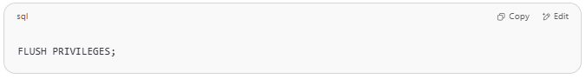
FLUSH PRIVILEGES;

Why the split?
- CREATE USER … IDENTIFIED BY handles password assignment.
- GRANT … TO only assigns privileges.
- This separation improves security and clarity.

Example Full Script
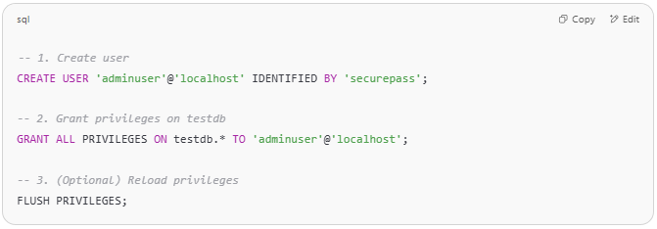
-- 1. Create user
CREATE USER 'adminuser'@'localhost' IDENTIFIED BY 'securepass';

-- 2. Grant privileges on testdb
GRANT ALL PRIVILEGES ON testdb.* TO 'adminuser'@'localhost';

-- 3. (Optional) Reload privileges
FLUSH PRIVILEGES;

After running the two commands above, you can verify with: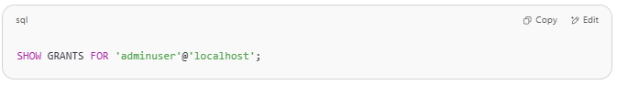
SHOW GRANTS FOR 'adminuser'@'localhost';

That should list something like:
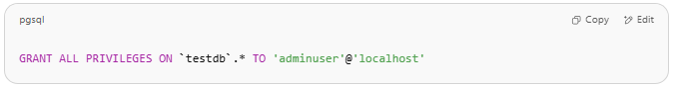
GRANT ALL PRIVILEGES ON `testdb`.* TO 'adminuser'@'localhost'

🌐 Granting on Specific Table
# Source: AI Source: Provided by: [Data Path: Persons Table -> ID Column: 1, Name_En Column: Motasem Essam] -> From: [ChatGPT] on [6/11/2026]
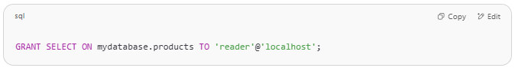
GRANT SELECT ON mydatabase.products TO 'reader'@'localhost';

This allows the user reader to read from the products table only.
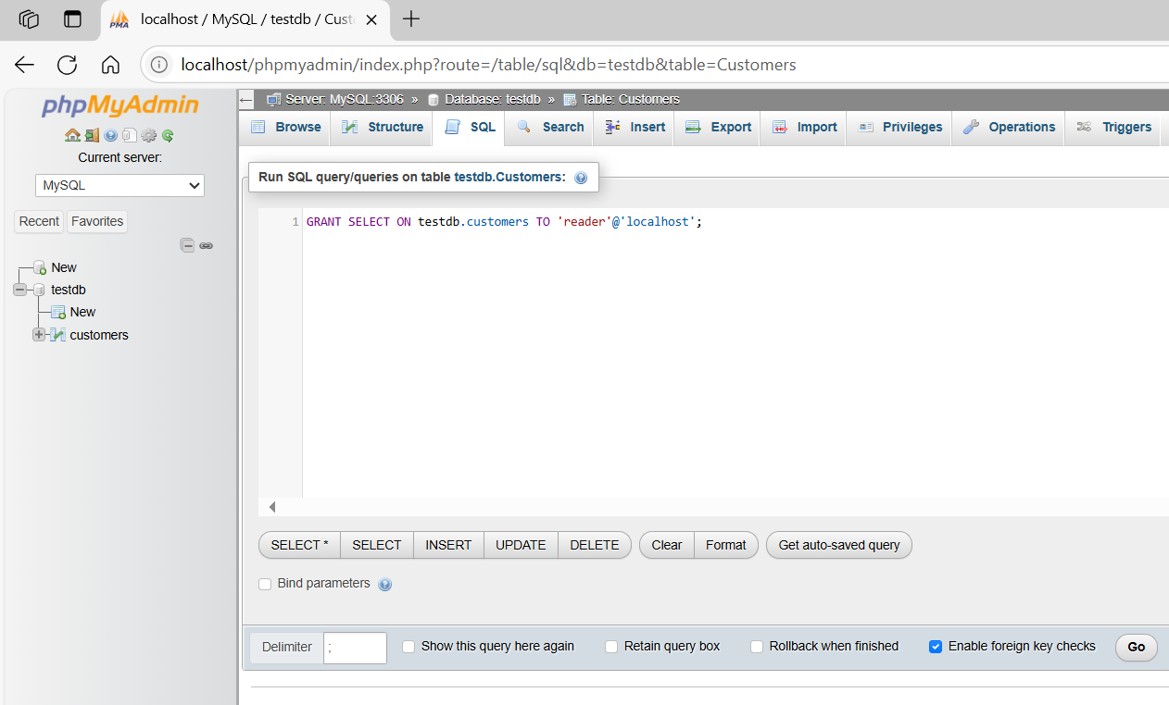
GRANT SELECT ON testdb.customers TO 'reader'@'localhost';
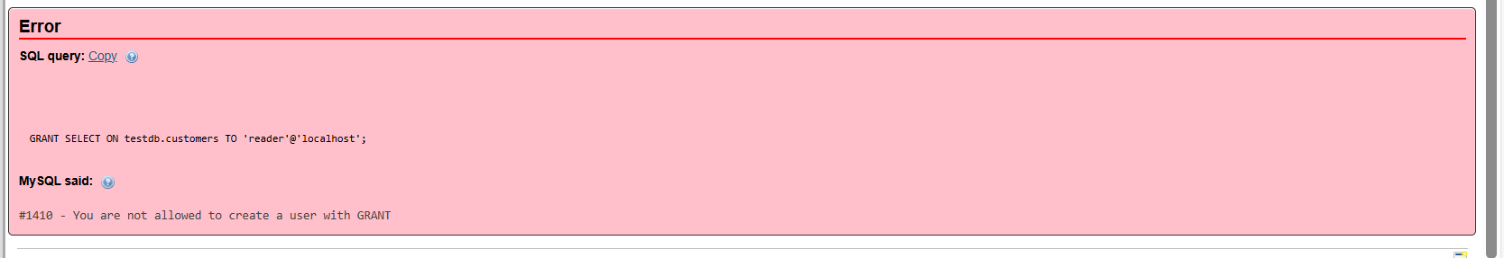
That error means your current account doesn’t have permission to both create the user and grant privileges in one go. In MySQL 8+ you must:
- Create the user (if it doesn’t already exist)
- Then GRANT privileges
And you must be logged in as someone with CREATE USER and/or GRANT OPTION rights (typically root).

1. Create the user first (if needed)
# Source: AI Source: Provided by: [Data Path: Persons Table -> ID Column: 1, Name_En Column: Motasem Essam] -> From: [ChatGPT] on [6/11/2026]
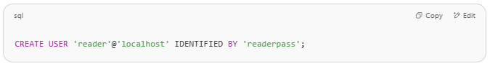
CREATE USER 'reader'@'localhost' IDENTIFIED BY 'readerpass';

If the user already exists, skip this step.

2. Grant the privilege
# Source: AI Source: Provided by: [Data Path: Persons Table -> ID Column: 1, Name_En Column: Motasem Essam] -> From: [ChatGPT] on [6/11/2026]
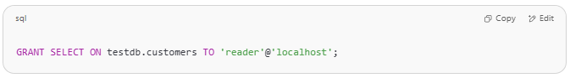
GRANT SELECT ON testdb.customers TO 'reader'@'localhost';

3. (Optional) Verify
# Source: AI Source: Provided by: [Data Path: Persons Table -> ID Column: 1, Name_En Column: Motasem Essam] -> From: [ChatGPT] on [6/11/2026]
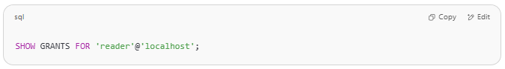
SHOW GRANTS FOR 'reader'@'localhost';

If you still see the same error:
# Source: AI Source: Provided by: [Data Path: Persons Table -> ID Column: 1, Name_En Column: Motasem Essam] -> From: [ChatGPT] on [6/11/2026]
- Check your own account’s privileges—you need CREATE USER and/or GRANT OPTION.
- Log in as root (or another admin user).
Only users with those rights can issue CREATE USER and GRANT commands.

🔄 Apply Changes
# Source: AI Source: Provided by: [Data Path: Persons Table -> ID Column: 1, Name_En Column: Motasem Essam] -> From: [ChatGPT] on [6/11/2026]
After changing privileges, run:
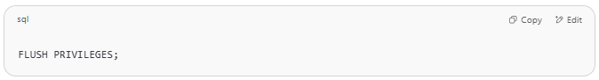
FLUSH PRIVILEGES;

🔁 This reloads the privilege tables, especially useful in older MySQL versions.

what is FLUSH PRIVILEGES; do
The FLUSH PRIVILEGES; statement tells the MySQL server to reload the in‑memory copy of its grant tables (the tables in the mysql schema that store user accounts and privileges) from disk.

When You Need It
- Pre‑MySQL‑8 (and some older MySQL setups):
After you manually edited the grant tables (mysql.user, mysql.db, etc.) with INSERT, UPDATE, or DELETE statements, MySQL doesn’t automatically pick up those changes. Running FLUSH PRIVILEGES; makes the server re‑read those tables so your manual edits take effect immediately.
- With GRANT/REVOKE/CREATE USER:
In modern MySQL (8.0+), these statements automatically reload the grant tables for you, so you generally don’t need to run FLUSH PRIVILEGES; after using them.

What It Does under the Hood
- Closes the in‑memory privilege tables
- Re‑opens and re‑loads them from the mysql database on disk
This ensures that any direct changes to those tables (outside of the privileged DCL commands) are recognized by the server.

Syntax
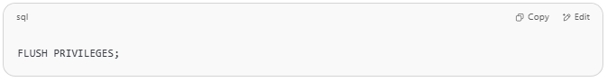
FLUSH PRIVILEGES;

❖ No options or qualifiers—just run it as a standalone command.

Key Takeaways
- Use it if you’ve manually manipulated the grant tables.
- Not required after GRANT/REVOKE/CREATE USER in MySQL 8+.
- Has no effect on normal DML or DDL operations—only on the grant tables.

👀 Check User Privileges
# Source: AI Source: Provided by: [Data Path: Persons Table -> ID Column: 1, Name_En Column: Motasem Essam] -> From: [ChatGPT] on [6/11/2026]
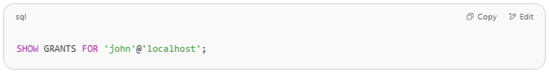
SHOW GRANTS FOR 'john'@'localhost';

⚠️ Important Notes
# Source: AI Source: Provided by: [Data Path: Persons Table -> ID Column: 1, Name_En Column: Motasem Essam] -> From: [ChatGPT] on [6/11/2026]
- You must be root or have GRANT OPTION to give privileges to others.
- If the user doesn’t exist, you must use CREATE USER first.
- In MySQL 8.0+, password must be set with CREATE USER or ALTER USER, not in GRANT.

Example

prepared commands
# Source: ScreenShot Source: Provided by: [Persons Table -> ID Column: 1, Name_En Column: Motasem Essam] -> Tool: [Automation Table -> ID Column: 16, Name_En Column: Screen Capture] -> From [Operating System: Wampserver64 -> phpmyadmin] on [6/11/2026]
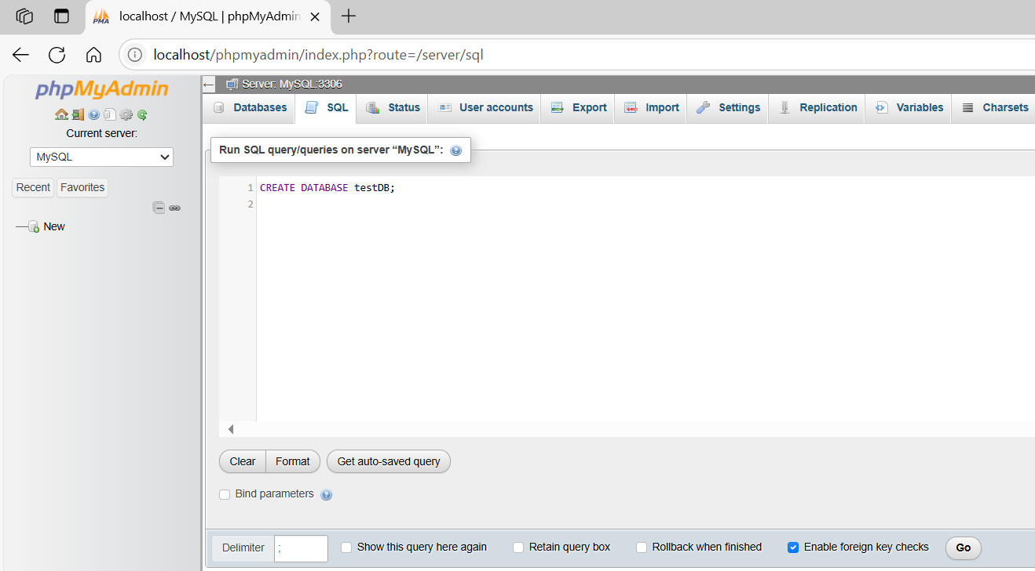
CREATE DATABASE testDB;
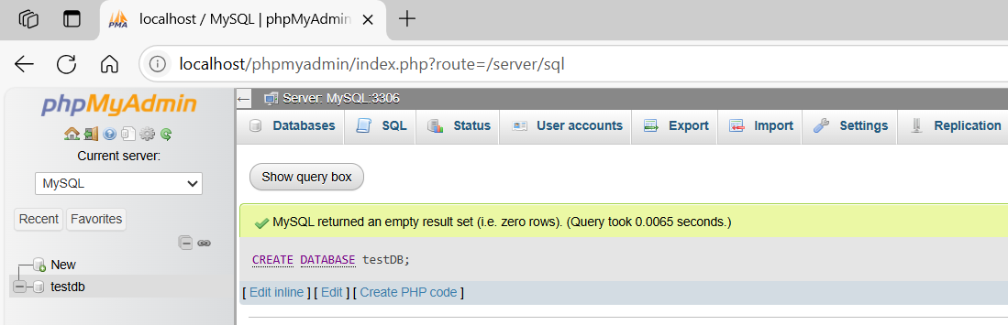
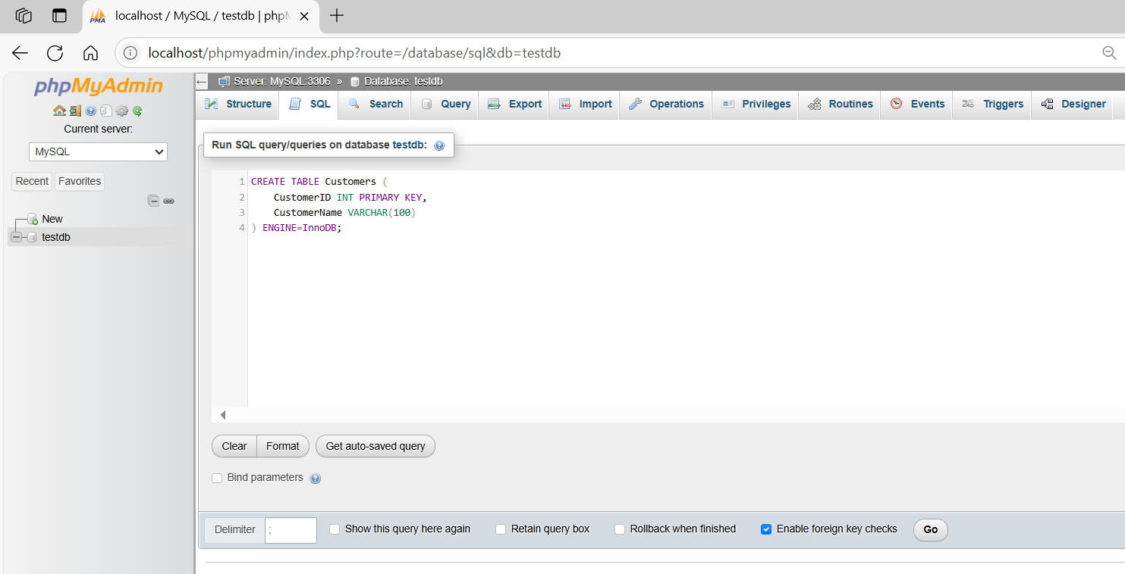
CREATE TABLE Customers (
CustomerID INT PRIMARY KEY,
CustomerName VARCHAR(100)
) ENGINE=InnoDB;
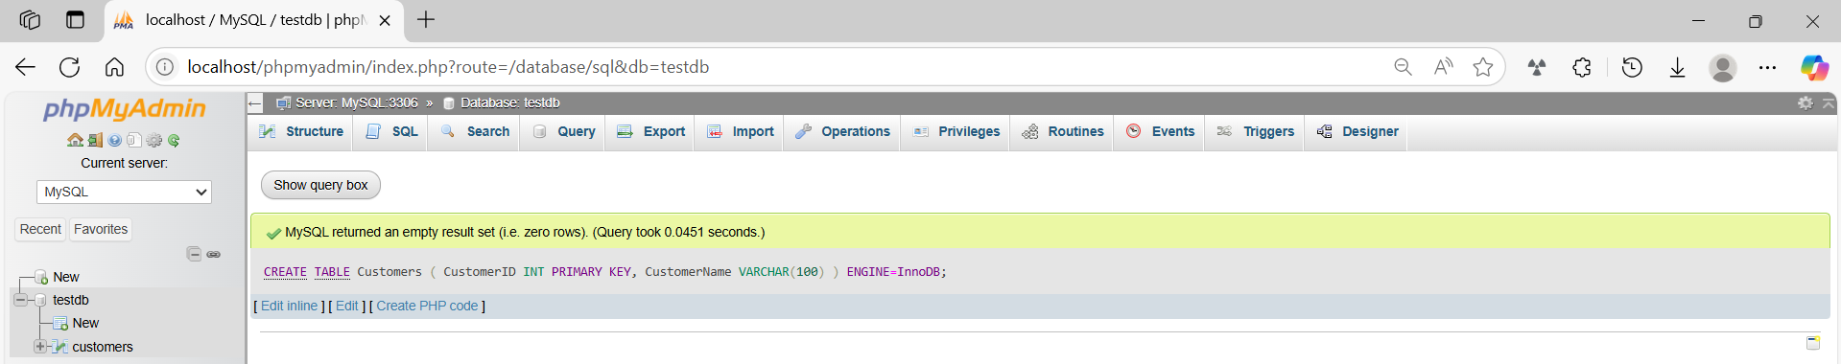

basic command
# Source: ScreenShot Source: Provided by: [Persons Table -> ID Column: 1, Name_En Column: Motasem Essam] -> Tool: [Automation Table -> ID Column: 16, Name_En Column: Screen Capture] -> From [Operating System: Wampserver64 -> phpmyadmin] on [6/11/2026]
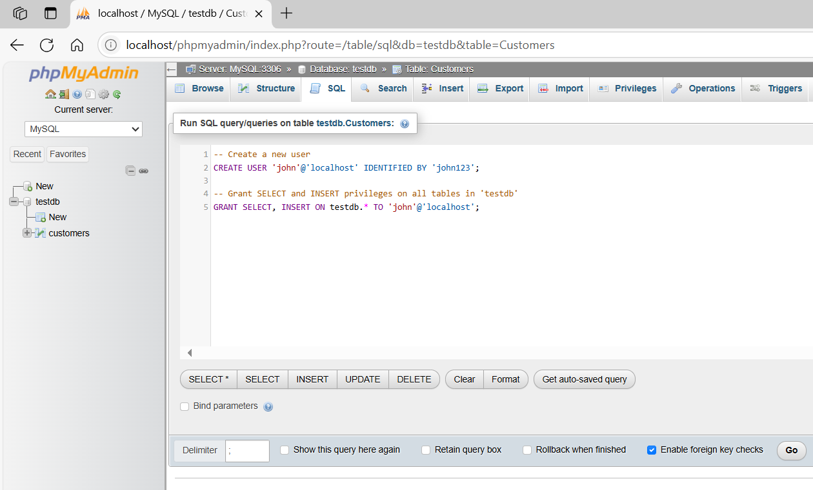
-- Create a new user
CREATE USER 'john'@'localhost' IDENTIFIED BY 'john123';

-- Grant SELECT and INSERT privileges on all tables in 'testdb'
GRANT SELECT, INSERT ON testdb.* TO 'john'@'localhost';
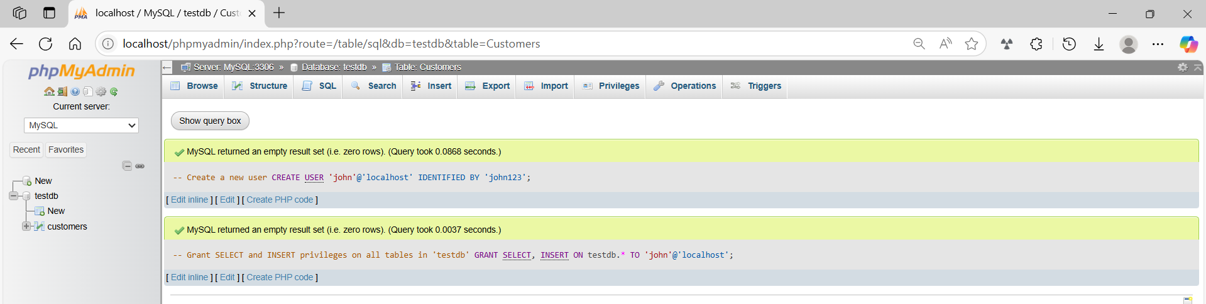

basic command
# Source: ScreenShot Source: Provided by: [Persons Table -> ID Column: 1, Name_En Column: Motasem Essam] -> Tool: [Automation Table -> ID Column: 16, Name_En Column: Screen Capture] -> From [Operating System: Wampserver64 -> phpmyadmin] on [6/11/2026]
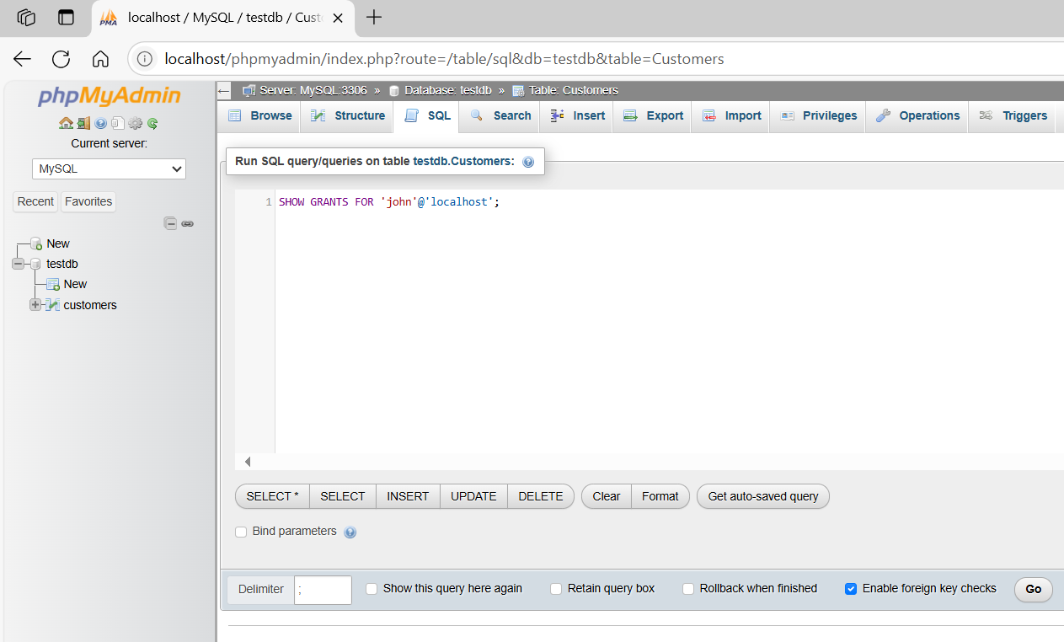
SHOW GRANTS FOR 'john'@'localhost';
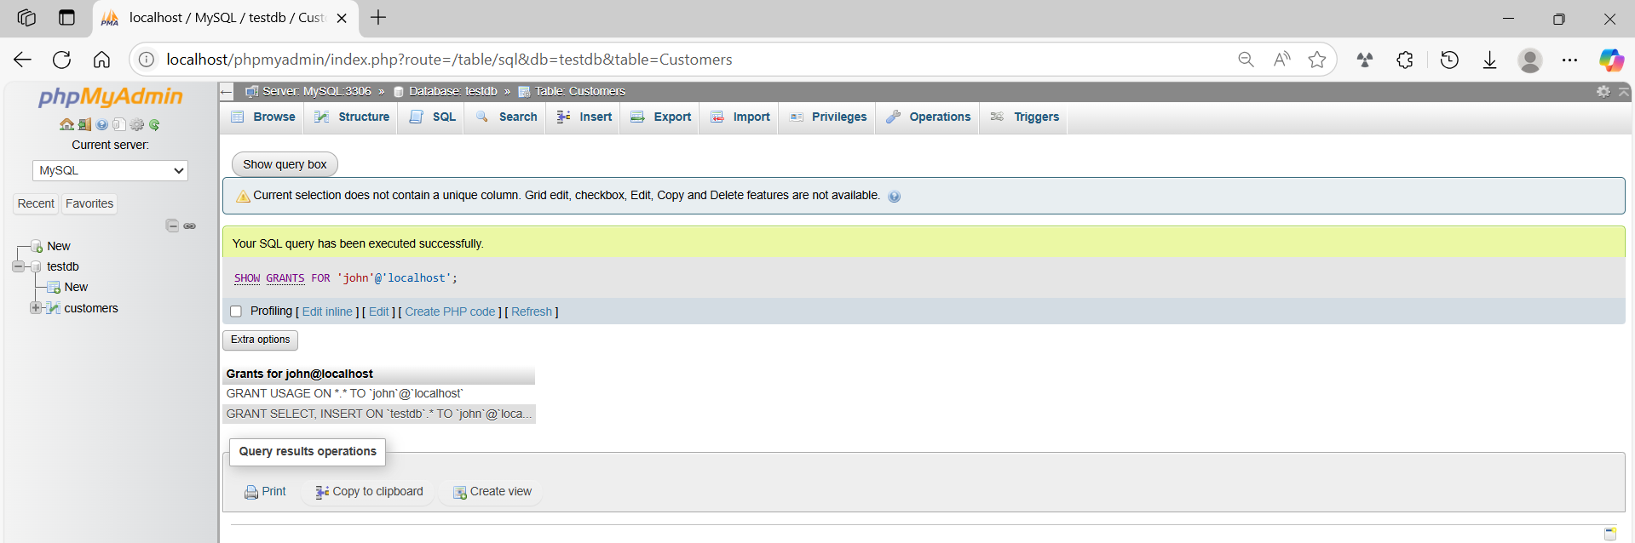

basic command
# Source: ScreenShot Source: Provided by: [Persons Table -> ID Column: 1, Name_En Column: Motasem Essam] -> Tool: [Automation Table -> ID Column: 16, Name_En Column: Screen Capture] -> From [Operating System: Wampserver64 -> phpmyadmin] on [6/11/2026]
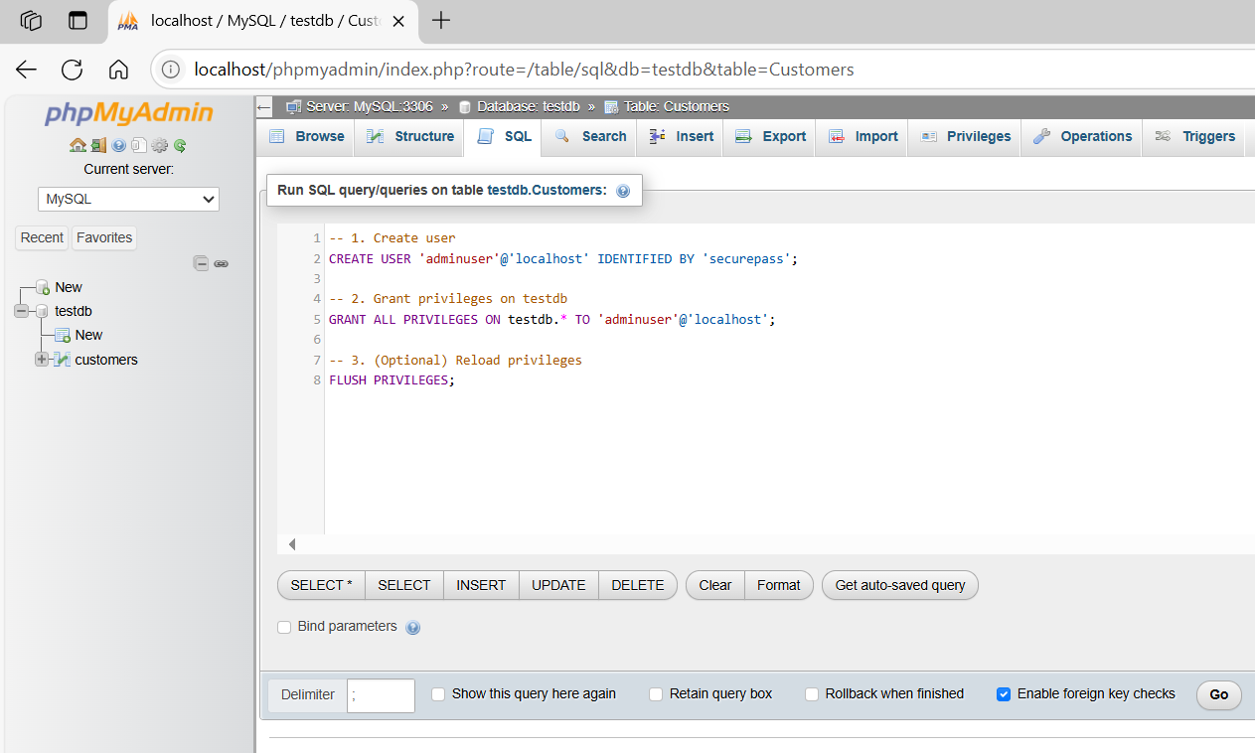
-- 1. Create user
CREATE USER 'adminuser'@'localhost' IDENTIFIED BY 'securepass';

-- 2. Grant privileges on testdb
GRANT ALL PRIVILEGES ON testdb.* TO 'adminuser'@'localhost';

-- 3. (Optional) Reload privileges
FLUSH PRIVILEGES;
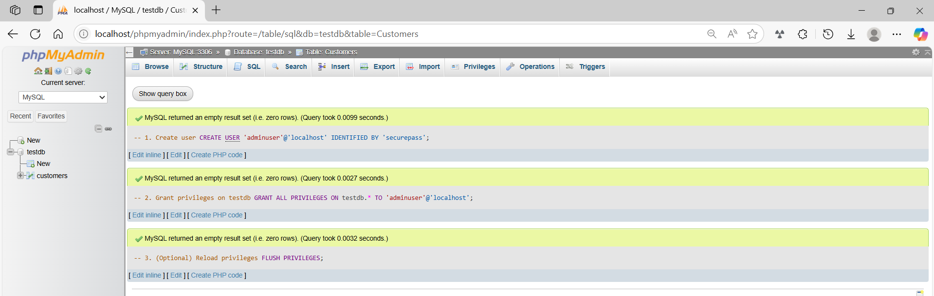
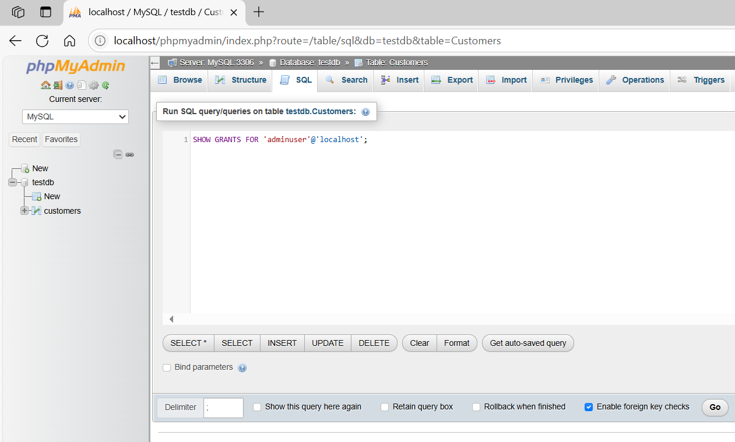
SHOW GRANTS FOR 'adminuser'@'localhost';
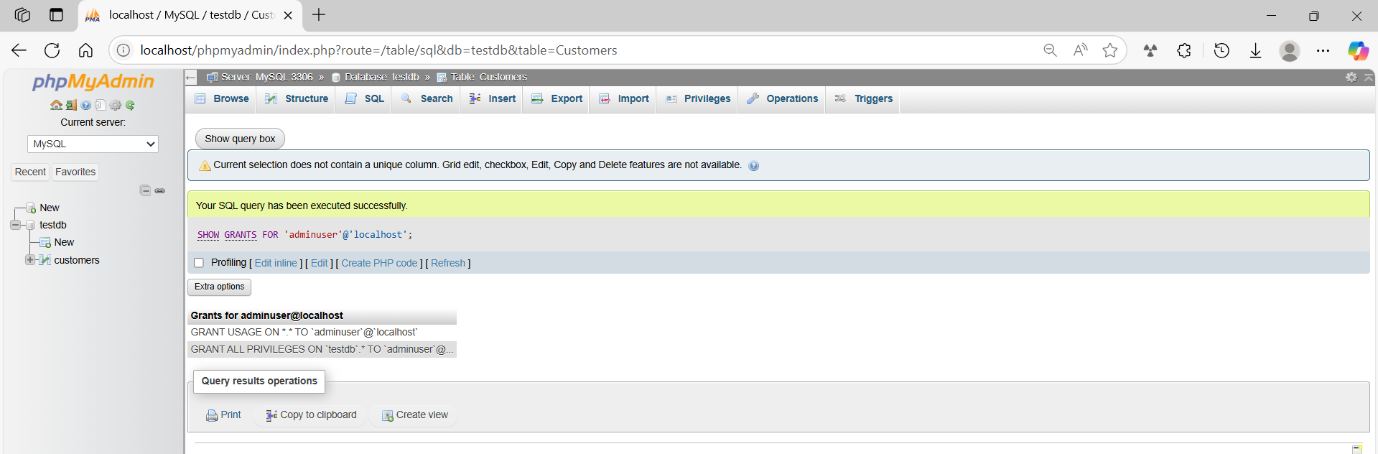

basic command
# Source: ScreenShot Source: Provided by: [Persons Table -> ID Column: 1, Name_En Column: Motasem Essam] -> Tool: [Automation Table -> ID Column: 16, Name_En Column: Screen Capture] -> From [Operating System: Wampserver64 -> phpmyadmin] on [6/11/2026]
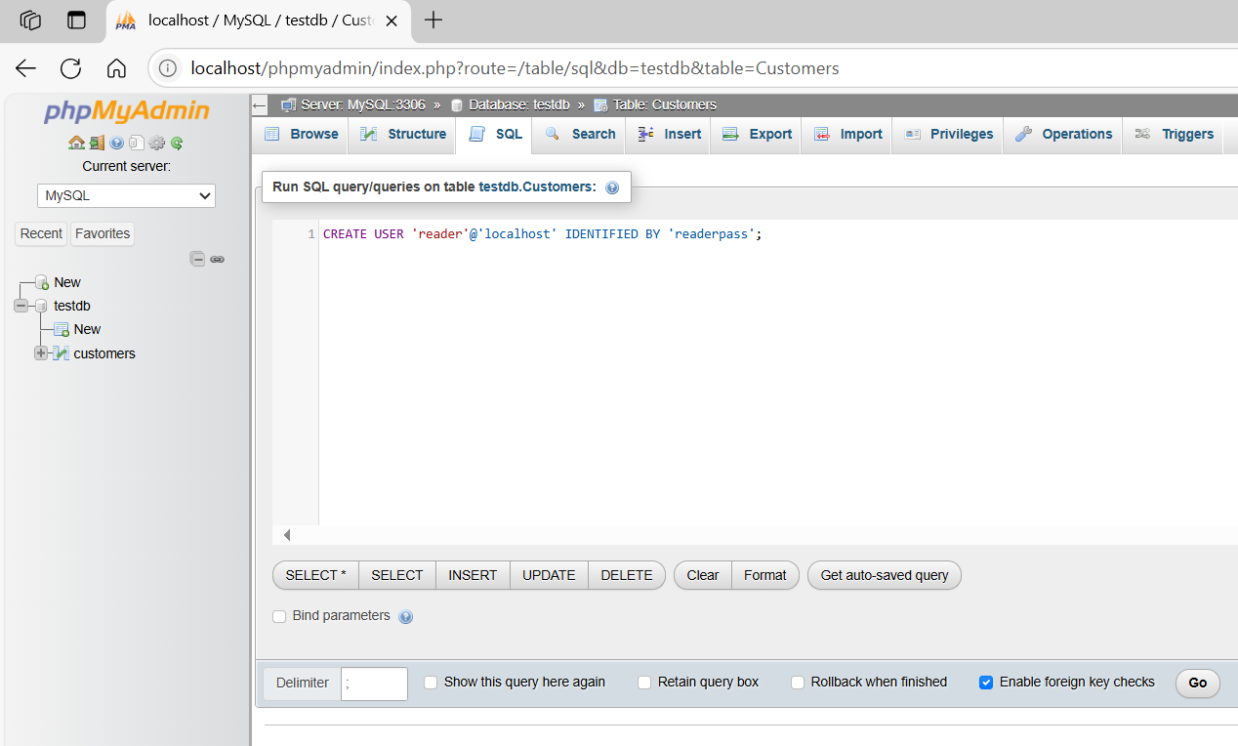
CREATE USER 'reader'@'localhost' IDENTIFIED BY 'readerpass';
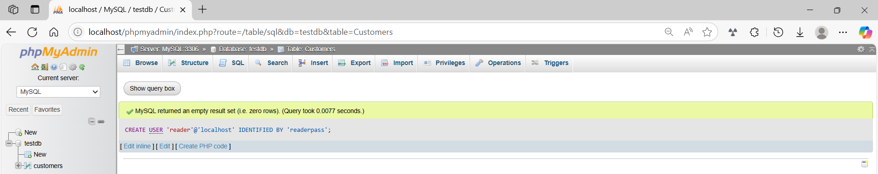
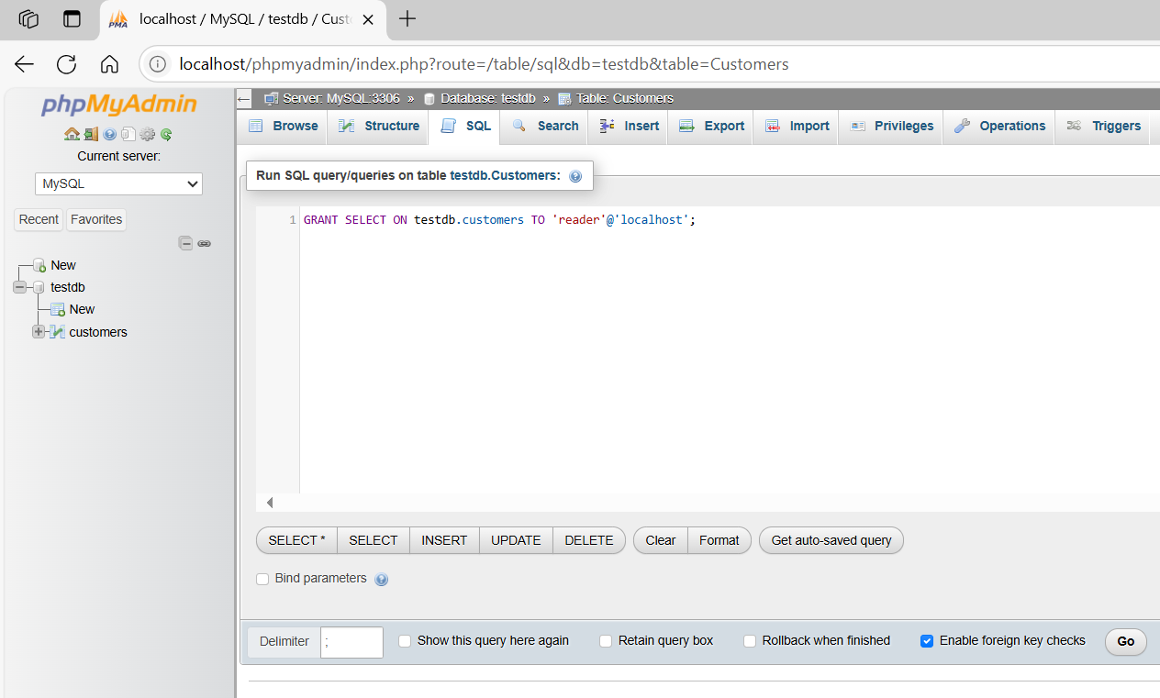
GRANT SELECT ON testdb.customers TO 'reader'@'localhost';
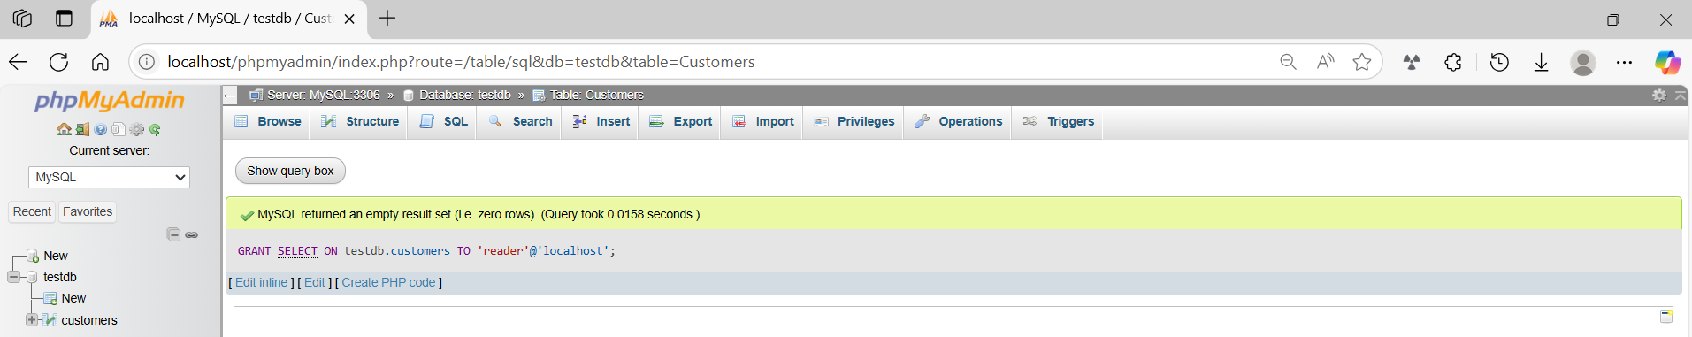
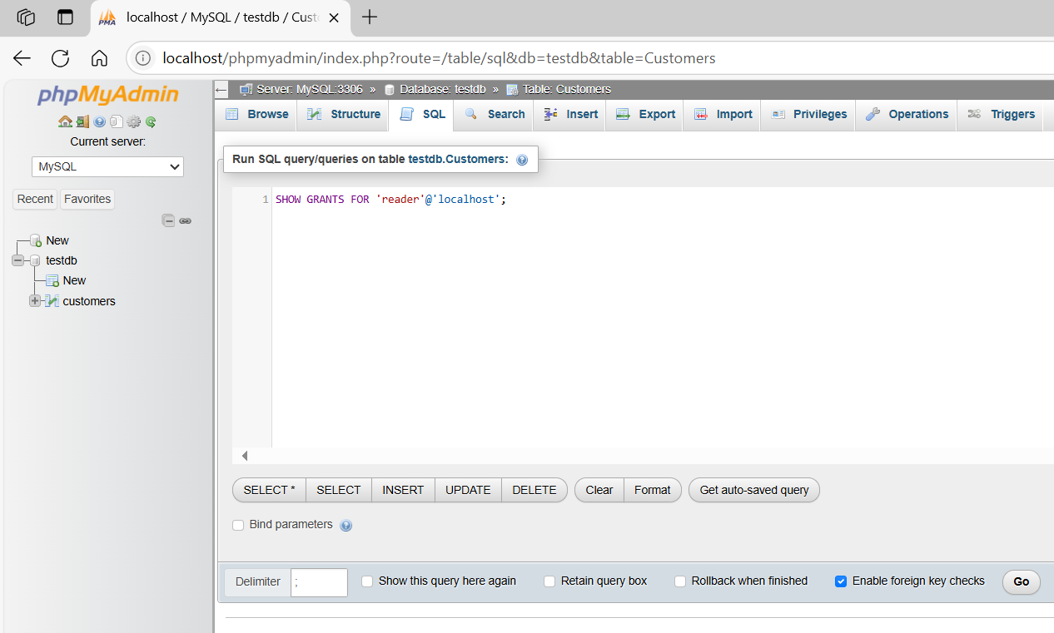
SHOW GRANTS FOR 'reader'@'localhost';
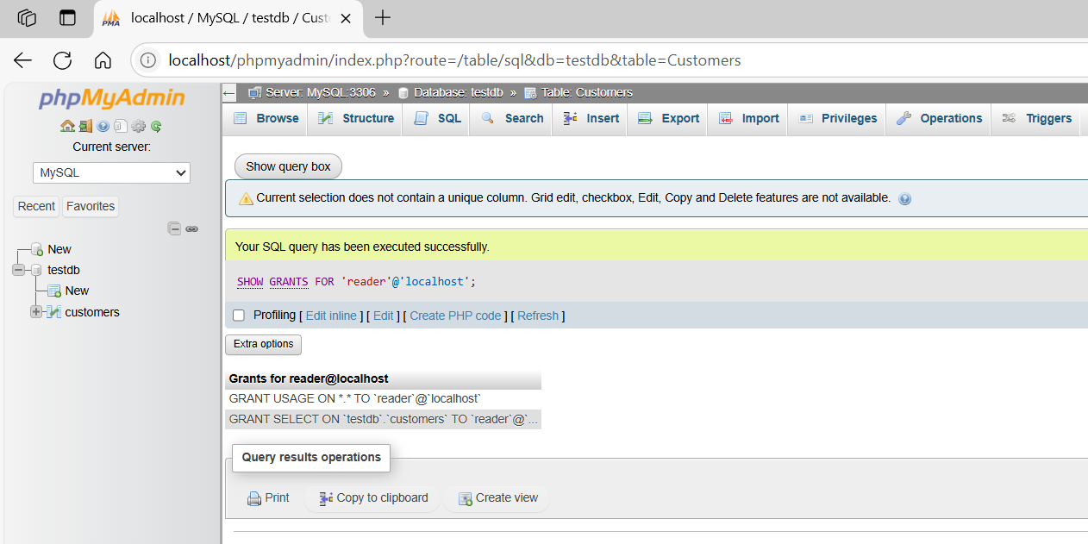

basic command
# Source: ScreenShot Source: Provided by: [Persons Table -> ID Column: 1, Name_En Column: Motasem Essam] -> Tool: [Automation Table -> ID Column: 16, Name_En Column: Screen Capture] -> From [Operating System: Wampserver64 -> phpmyadmin] on [6/11/2026]
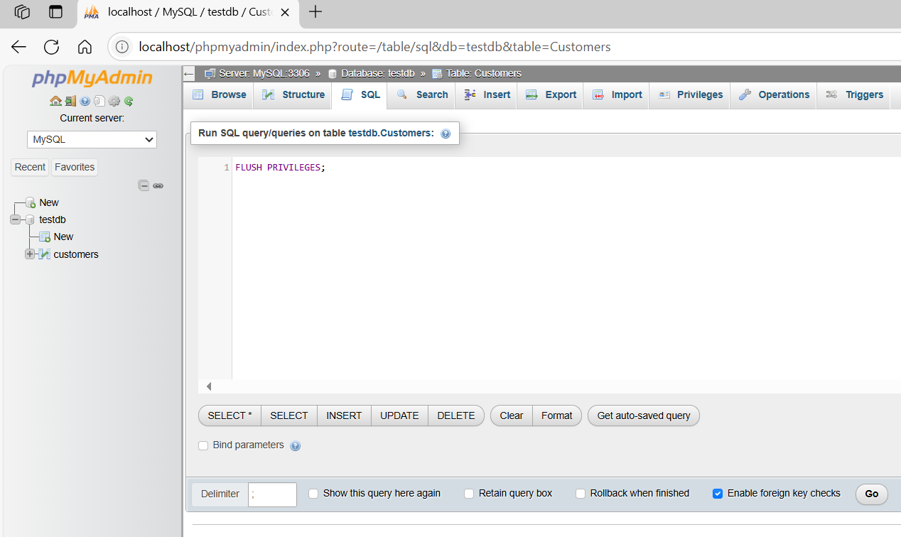
FLUSH PRIVILEGES;
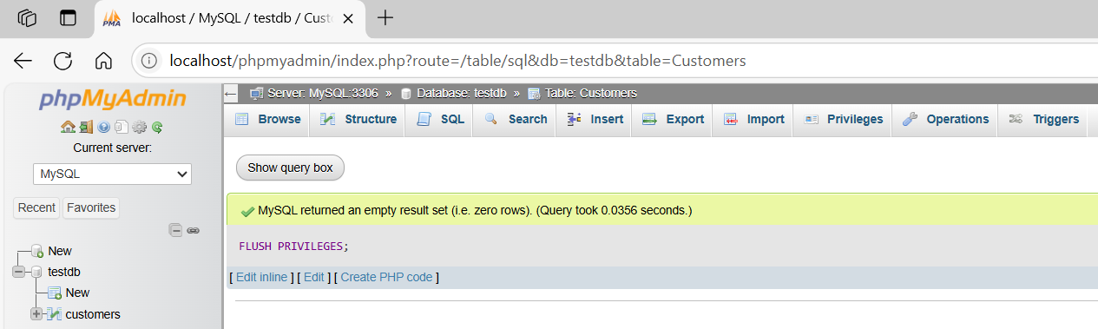

check all user PRIVILEGES
# Source: AI Source: Provided by: [Data Path: Persons Table -> ID Column: 1, Name_En Column: Motasem Essam] -> From: [ChatGPT] on [6/11/2026]
To check all users and their privileges in MySQL, here are a few methods depending on what exactly you want to see:

✅ 1. Check All Grants for All Users (One-by-One)
# Source: AI Source: Provided by: [Data Path: Persons Table -> ID Column: 1, Name_En Column: Motasem Essam] -> From: [ChatGPT] on [6/11/2026]
You can run this query to generate SHOW GRANTS statements for each user:
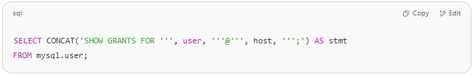
SELECT CONCAT('SHOW GRANTS FOR ''', user, '''@''', host, ''';') AS stmt
FROM mysql.user;

Then, copy and run the output statements to see each user’s privileges.
For example:
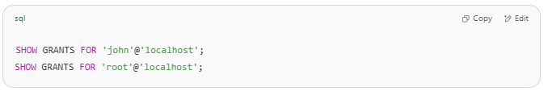
SHOW GRANTS FOR 'john'@'localhost';
SHOW GRANTS FOR 'root'@'localhost';

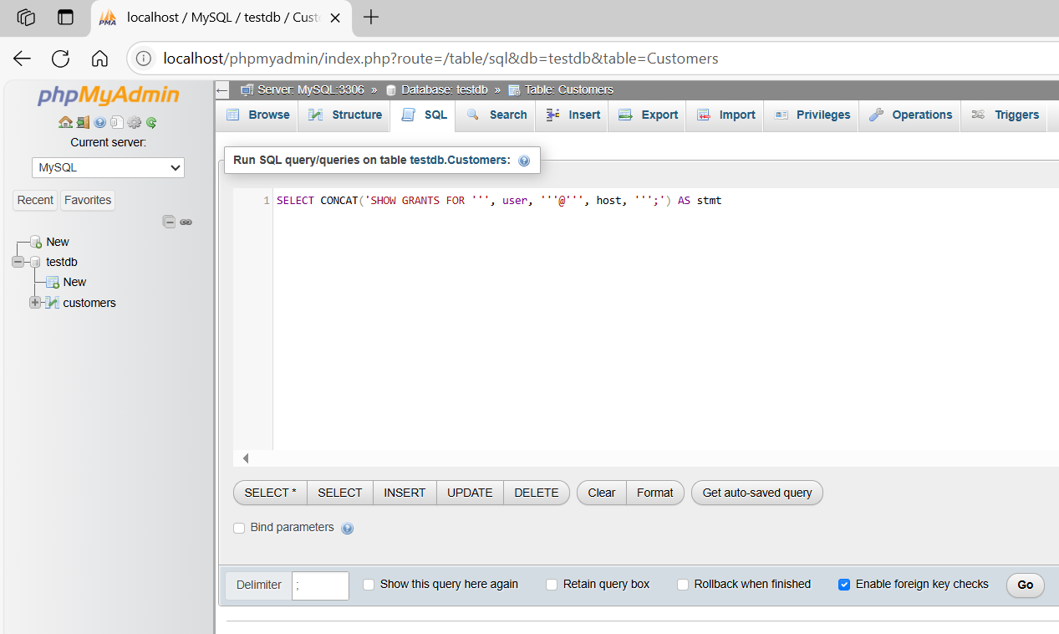
SELECT CONCAT('SHOW GRANTS FOR ''', user, '''@''', host, ''';') AS stmt
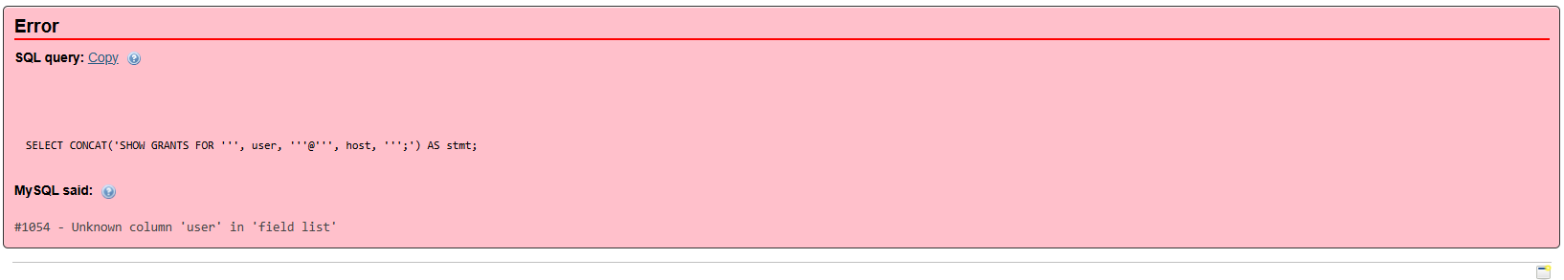
The error you're seeing: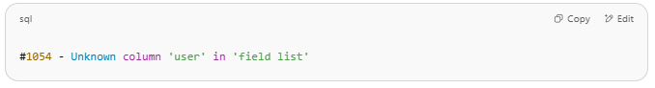
#1054 - Unknown column 'user' in 'field list'

means that the user column is not recognized in your SELECT statement. This usually happens when you're trying to run this query without specifying the correct table — in this case, mysql.user, which stores user and host information.

✅ Correct Query:
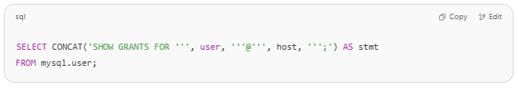
SELECT CONCAT('SHOW GRANTS FOR ''', user, '''@''', host, ''';') AS stmt
FROM mysql.user;

Explanation:
- You're selecting from the internal mysql.user table, which contains MySQL's user account data.
- You need privileges to read from this system table. If you're not logged in as root or another privileged user, this query may also fail due to permissions.
If You Still Get an Error
Make sure you're:
- Using MySQL, not MariaDB (syntax may differ slightly).
- Logged in as a user with privileges to read from mysql.user (e.g., root).
- Running the query on a server that allows access to the mysql system database.

✅ 2. Check Users and Their Hosts
# Source: AI Source: Provided by: [Data Path: Persons Table -> ID Column: 1, Name_En Column: Motasem Essam] -> From: [ChatGPT] on [6/11/2026]
To see all MySQL users and their host origins:
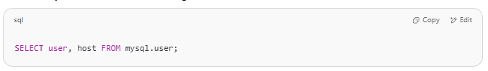
SELECT user, host FROM mysql.user;

✅ 3. Check Raw Privileges in mysql.user Table
# Source: AI Source: Provided by: [Data Path: Persons Table -> ID Column: 1, Name_En Column: Motasem Essam] -> From: [ChatGPT] on [6/11/2026]
You can directly query the mysql.user table to see all global privileges:
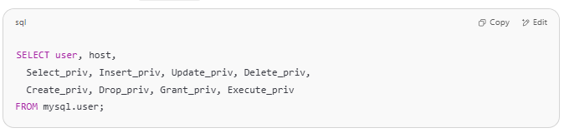
SELECT user, host,
Select_priv, Insert_priv, Update_priv, Delete_priv,
Create_priv, Drop_priv, Grant_priv, Execute_priv
FROM mysql.user;

📌 Note: This shows global-level privileges only. Privileges on specific databases/tables are stored in:
- mysql.db
- mysql.tables_priv
- mysql.columns_priv

✅ 4. Check Privileges on Specific Database
# Source: AI Source: Provided by: [Data Path: Persons Table -> ID Column: 1, Name_En Column: Motasem Essam] -> From: [ChatGPT] on [6/11/2026]
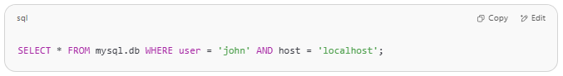
SELECT * FROM mysql.db WHERE user = 'john' AND host = 'localhost';

✅ 5. Check Current User’s Privileges
# Source: AI Source: Provided by: [Data Path: Persons Table -> ID Column: 1, Name_En Column: Motasem Essam] -> From: [ChatGPT] on [6/11/2026]
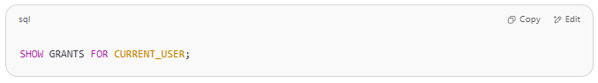
SHOW GRANTS FOR CURRENT_USER;

Let me know if you want a script to loop through all users and print all their grants automatically.
Here is a script to automatically list all SHOW GRANTS statements for all users and execute them to display each user's privileges in MySQL.
✅ Works best when run in a MySQL client like MySQL Workbench, phpMyAdmin (one-at-a-time), or a scripting tool (like Python or Bash with MySQL CLI).

🧾 Step-by-step SQL Script (Manual Execution)
# Source: AI Source: Provided by: [Data Path: Persons Table -> ID Column: 1, Name_En Column: Motasem Essam] -> From: [ChatGPT] on [6/11/2026]
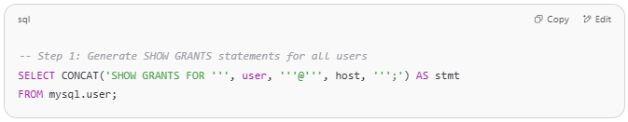
-- Step 1: Generate SHOW GRANTS statements for all users
SELECT CONCAT('SHOW GRANTS FOR ''', user, '''@''', host, ''';') AS stmt
FROM mysql.user;

👉 This will return output like:
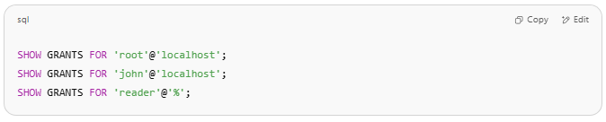
SHOW GRANTS FOR 'root'@'localhost';
SHOW GRANTS FOR 'john'@'localhost';
SHOW GRANTS FOR 'reader'@'%';

🧪 Step 2: Copy and Run Each Output
# Source: AI Source: Provided by: [Data Path: Persons Table -> ID Column: 1, Name_En Column: Motasem Essam] -> From: [ChatGPT] on [6/11/2026]
Run each SHOW GRANTS statement to see the privileges for that user:
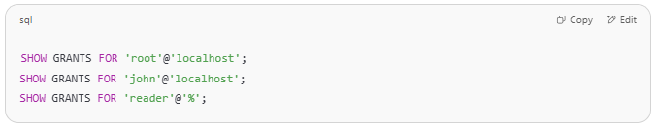
SHOW GRANTS FOR 'root'@'localhost';
SHOW GRANTS FOR 'john'@'localhost';
SHOW GRANTS FOR 'reader'@'%';

This will display results like:
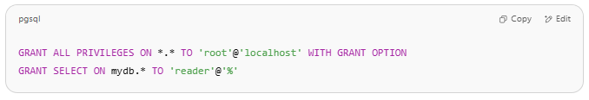
GRANT ALL PRIVILEGES ON *.* TO 'root'@'localhost' WITH GRANT OPTION
GRANT SELECT ON mydb.* TO 'reader'@'%'

🛠️ Optional: Full Bash Script for Automation (if you're using terminal)
# Source: AI Source: Provided by: [Data Path: Persons Table -> ID Column: 1, Name_En Column: Motasem Essam] -> From: [ChatGPT] on [6/11/2026]
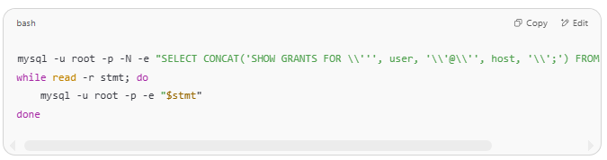
mysql -u root -p -N -e "SELECT CONCAT('SHOW GRANTS FOR \\''', user, '\\'@\\'', host, '\\';') FROM mysql.user;" | \
while read -r stmt; do
mysql -u root -p -e "$stmt"
done

It will prompt for the password and then loop through all users, showing their grants.

Example

prepared commands
# Source: ScreenShot Source: Provided by: [Persons Table -> ID Column: 1, Name_En Column: Motasem Essam] -> Tool: [Automation Table -> ID Column: 16, Name_En Column: Screen Capture] -> From [Operating System: Wampserver64 -> phpmyadmin] on [6/11/2026]

CREATE DATABASE testDB;


CREATE TABLE Customers (
CustomerID INT PRIMARY KEY,
CustomerName VARCHAR(100)
) ENGINE=InnoDB;


basic command
# Source: ScreenShot Source: Provided by: [Persons Table -> ID Column: 1, Name_En Column: Motasem Essam] -> Tool: [Automation Table -> ID Column: 16, Name_En Column: Screen Capture] -> From [Operating System: Wampserver64 -> phpmyadmin] on [6/11/2026]
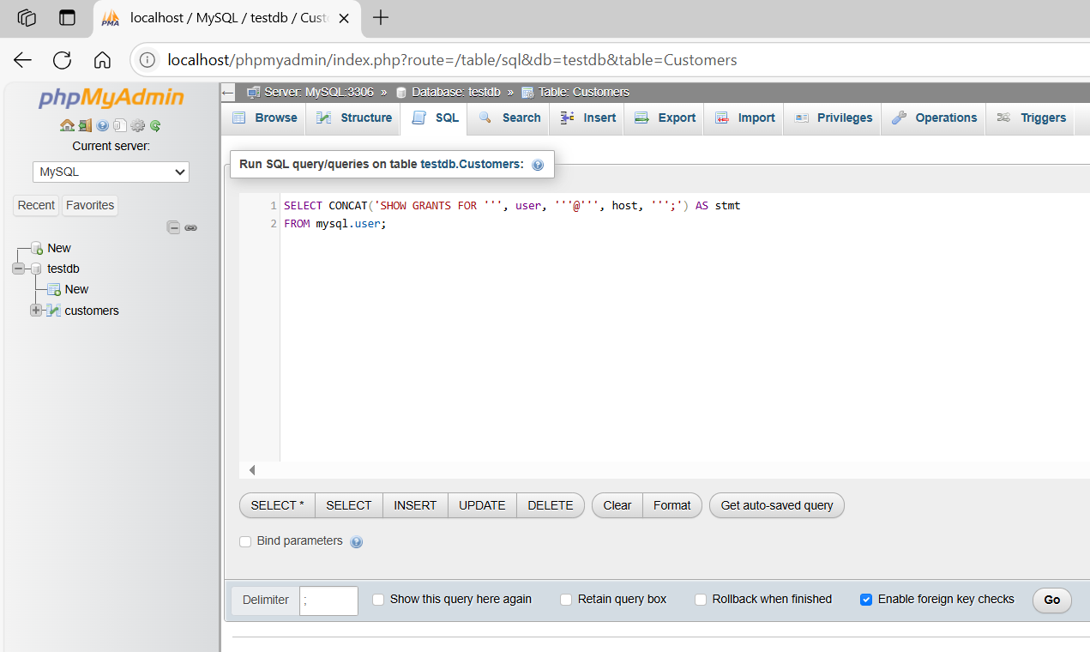
SELECT CONCAT('SHOW GRANTS FOR ''', user, '''@''', host, ''';') AS stmt
FROM mysql.user;
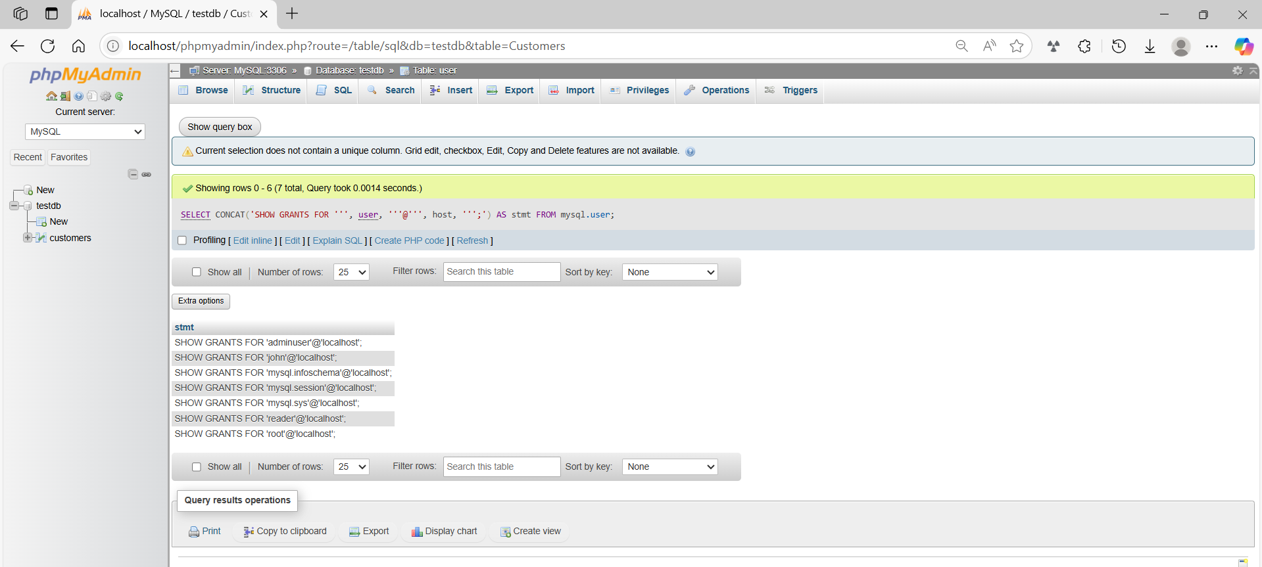
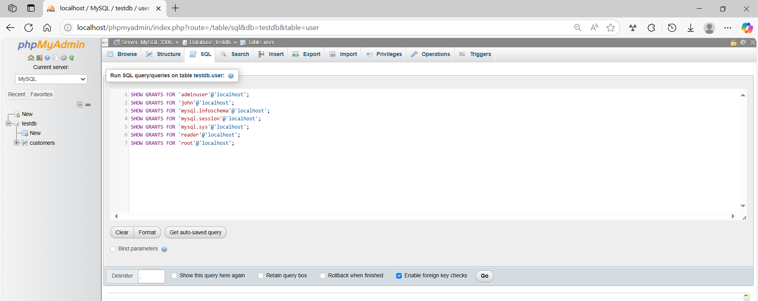
SHOW GRANTS FOR 'adminuser'@'localhost';
SHOW GRANTS FOR 'john'@'localhost';
SHOW GRANTS FOR 'mysql.infoschema'@'localhost';
SHOW GRANTS FOR 'mysql.session'@'localhost';
SHOW GRANTS FOR 'mysql.sys'@'localhost';
SHOW GRANTS FOR 'reader'@'localhost';
SHOW GRANTS FOR 'root'@'localhost';
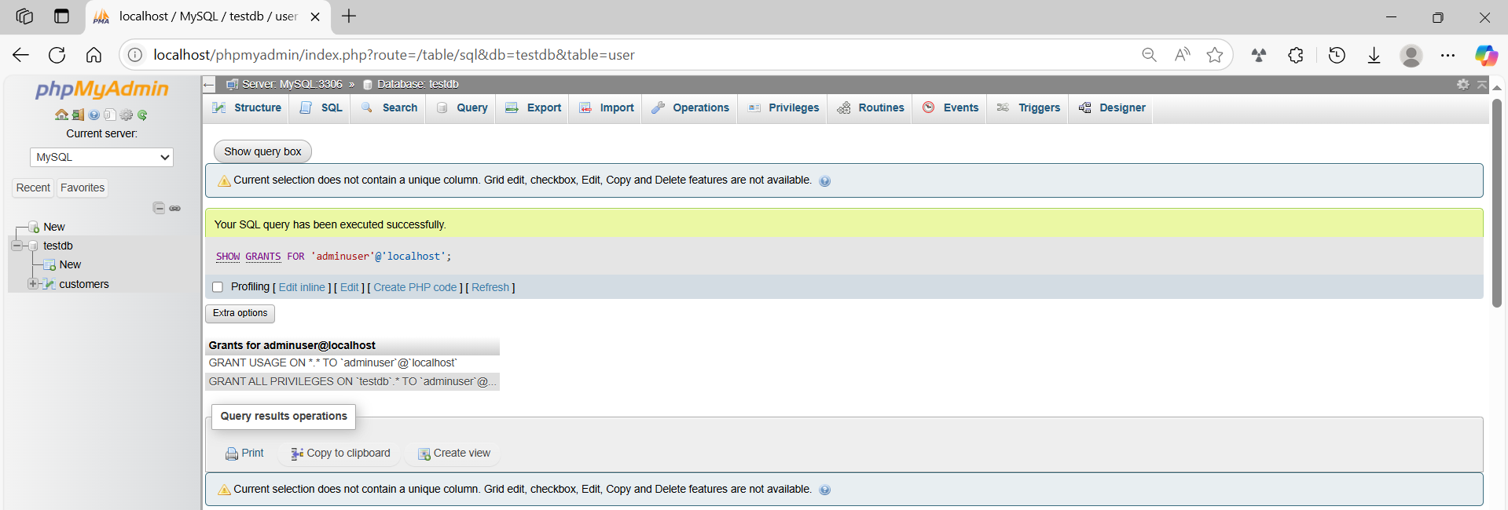
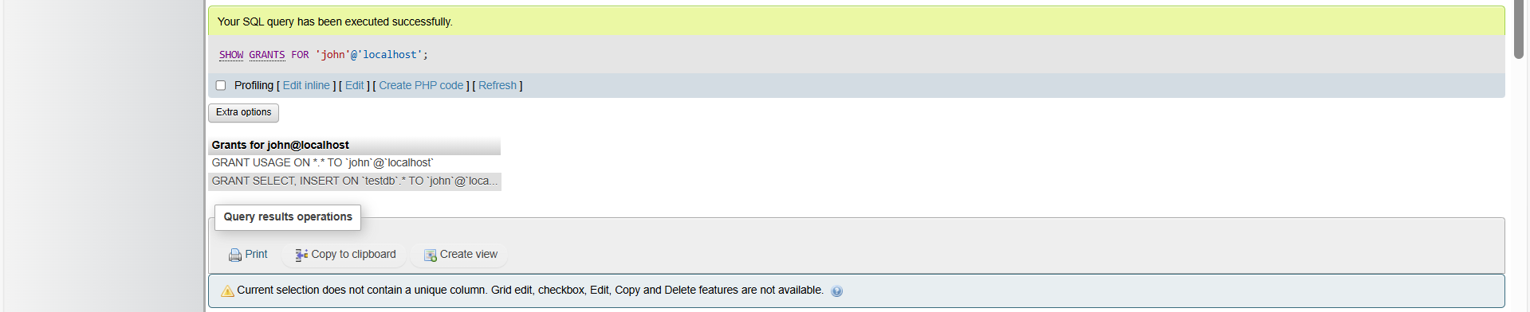
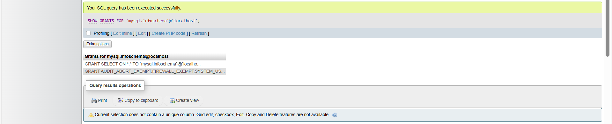
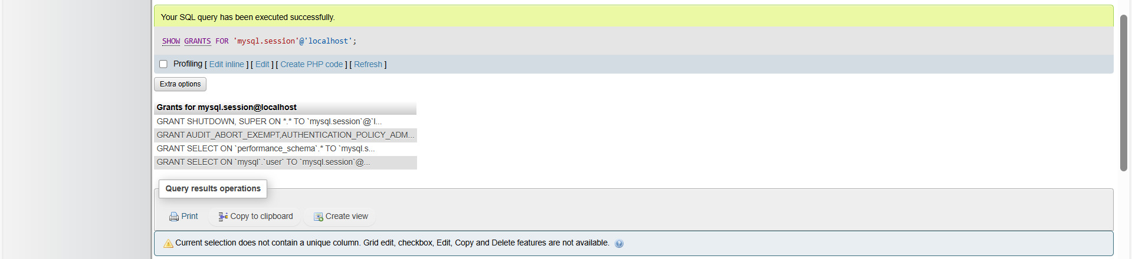
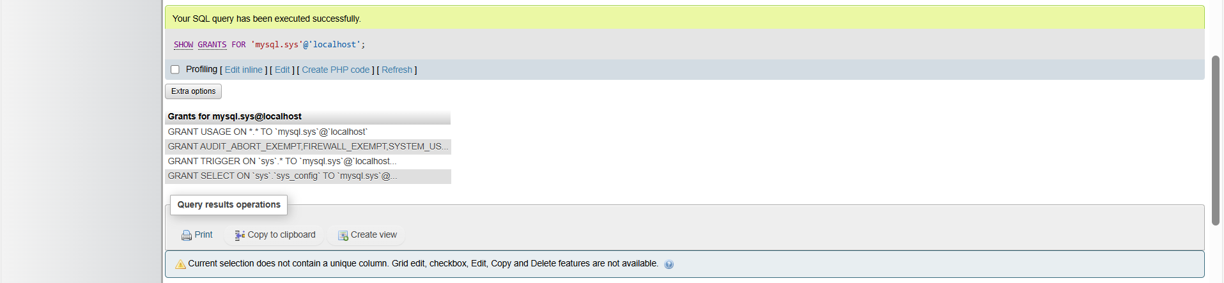
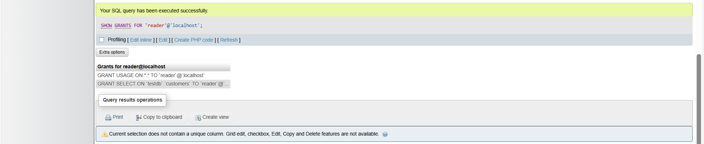


basic command
# Source: ScreenShot Source: Provided by: [Persons Table -> ID Column: 1, Name_En Column: Motasem Essam] -> Tool: [Automation Table -> ID Column: 16, Name_En Column: Screen Capture] -> From [Operating System: Wampserver64 -> phpmyadmin] on [6/11/2026]
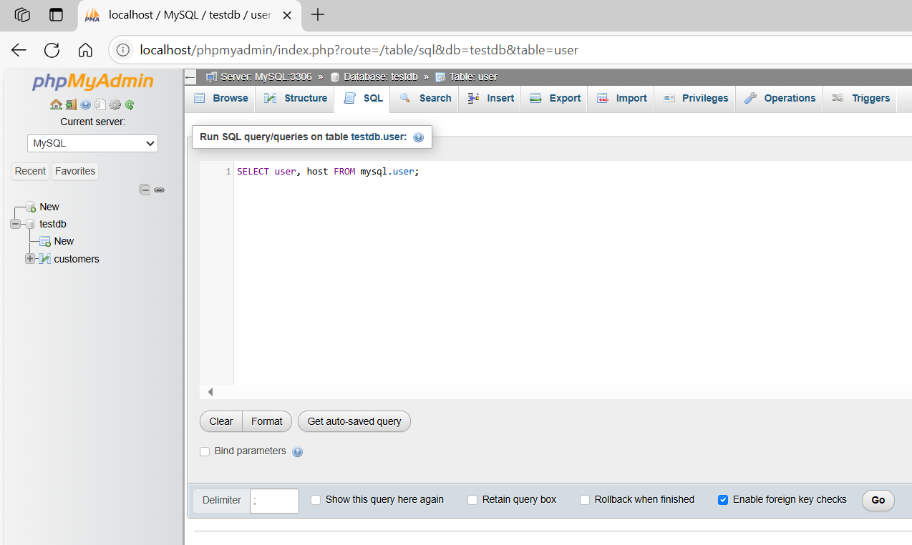
SELECT user, host FROM mysql.user;
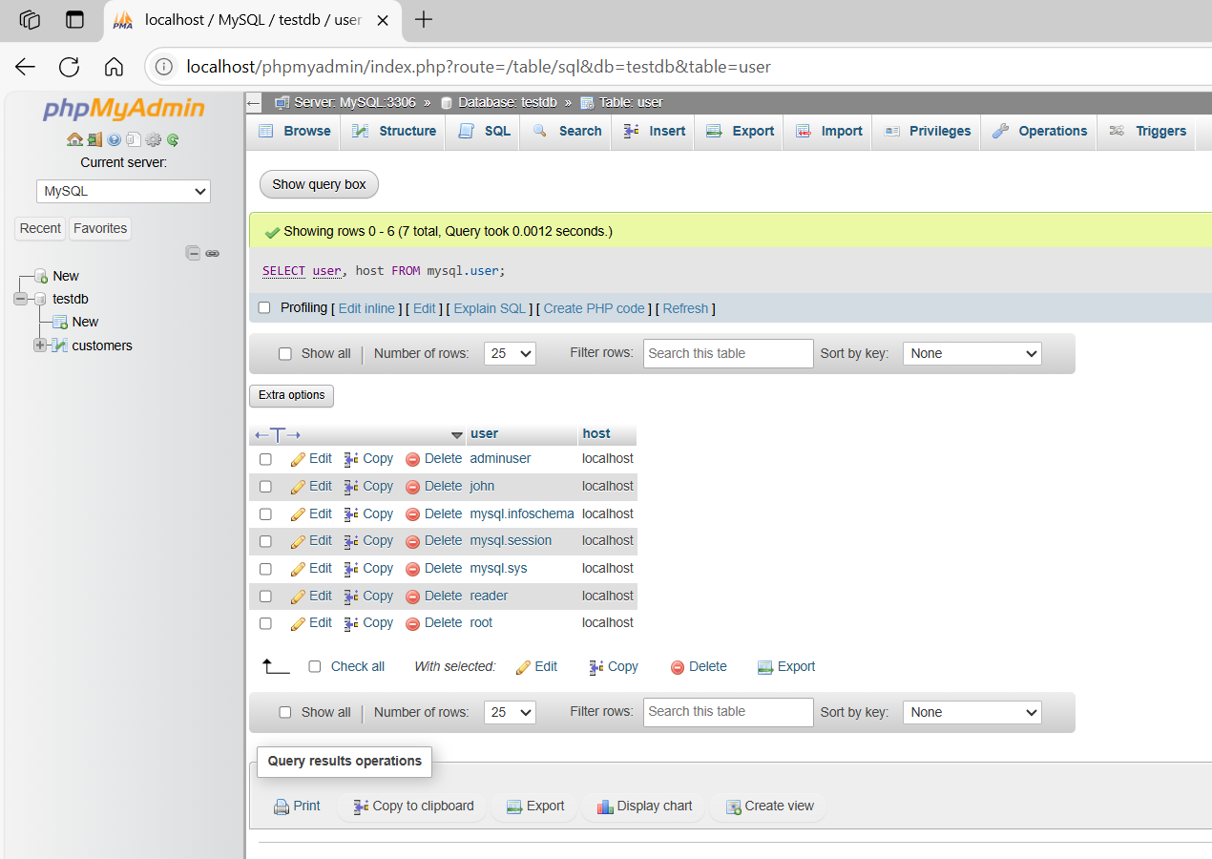

basic command
# Source: ScreenShot Source: Provided by: [Persons Table -> ID Column: 1, Name_En Column: Motasem Essam] -> Tool: [Automation Table -> ID Column: 16, Name_En Column: Screen Capture] -> From [Operating System: Wampserver64 -> phpmyadmin] on [6/11/2026]
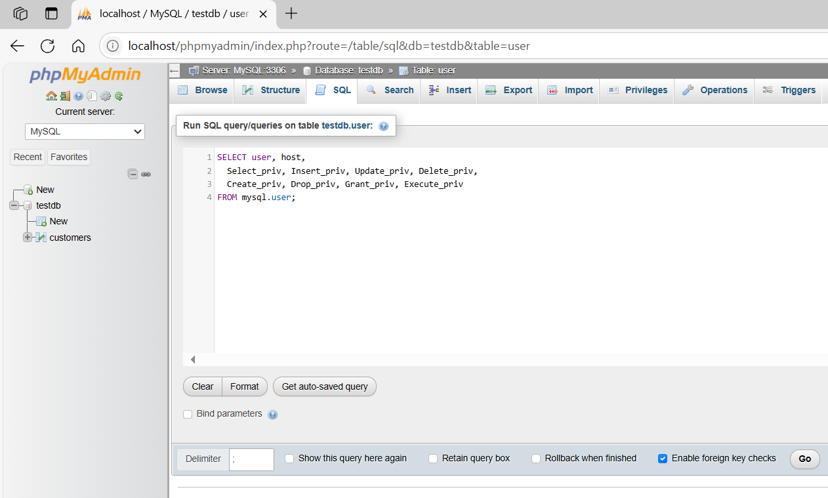
SELECT user, host,
Select_priv, Insert_priv, Update_priv, Delete_priv,
Create_priv, Drop_priv, Grant_priv, Execute_priv
FROM mysql.user;
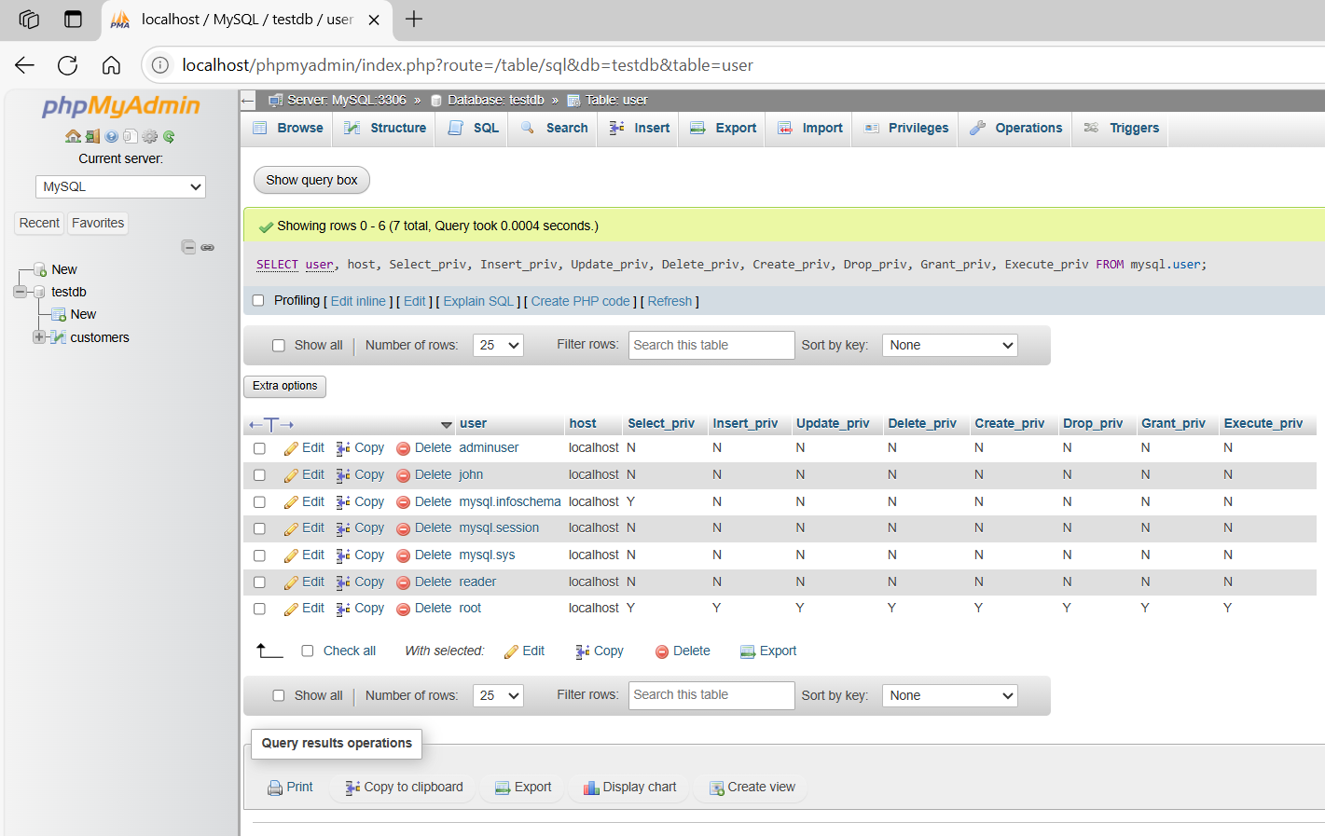

basic command
# Source: ScreenShot Source: Provided by: [Persons Table -> ID Column: 1, Name_En Column: Motasem Essam] -> Tool: [Automation Table -> ID Column: 16, Name_En Column: Screen Capture] -> From [Operating System: Wampserver64 -> phpmyadmin] on [6/11/2026]
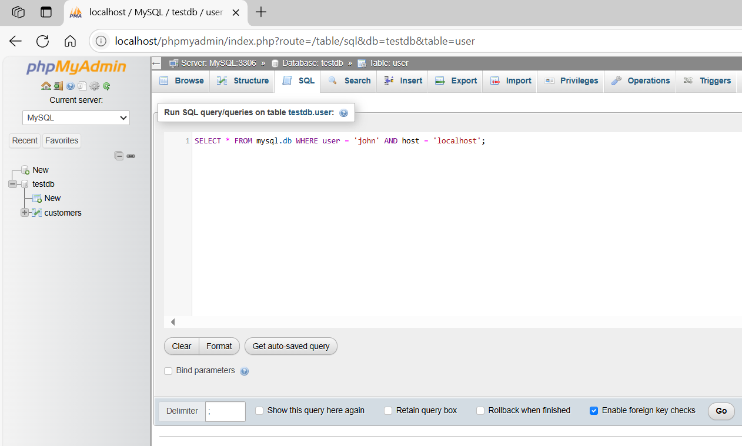
SELECT * FROM mysql.db WHERE user = 'john' AND host = 'localhost';
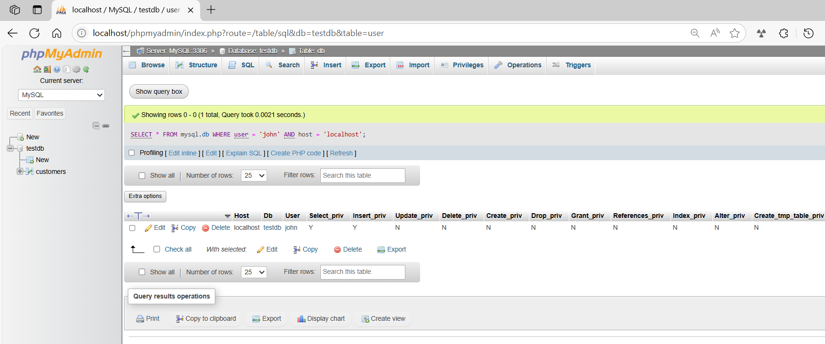
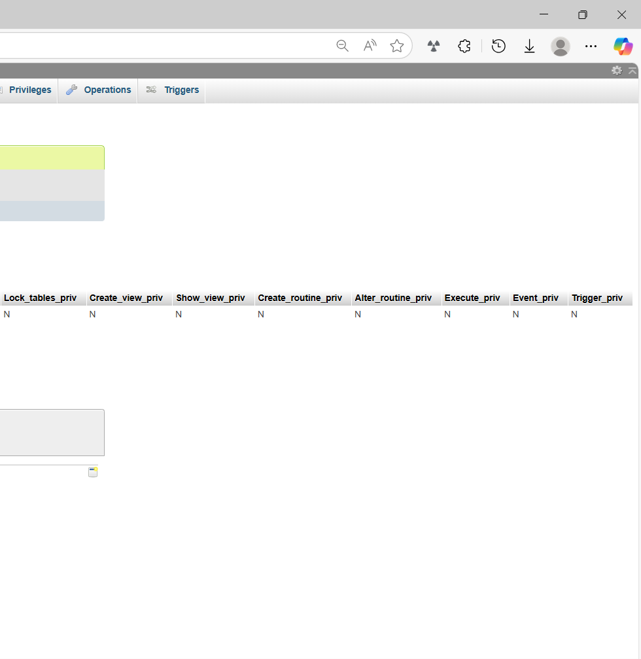

basic command
# Source: ScreenShot Source: Provided by: [Persons Table -> ID Column: 1, Name_En Column: Motasem Essam] -> Tool: [Automation Table -> ID Column: 16, Name_En Column: Screen Capture] -> From [Operating System: Wampserver64 -> phpmyadmin] on [6/11/2026]
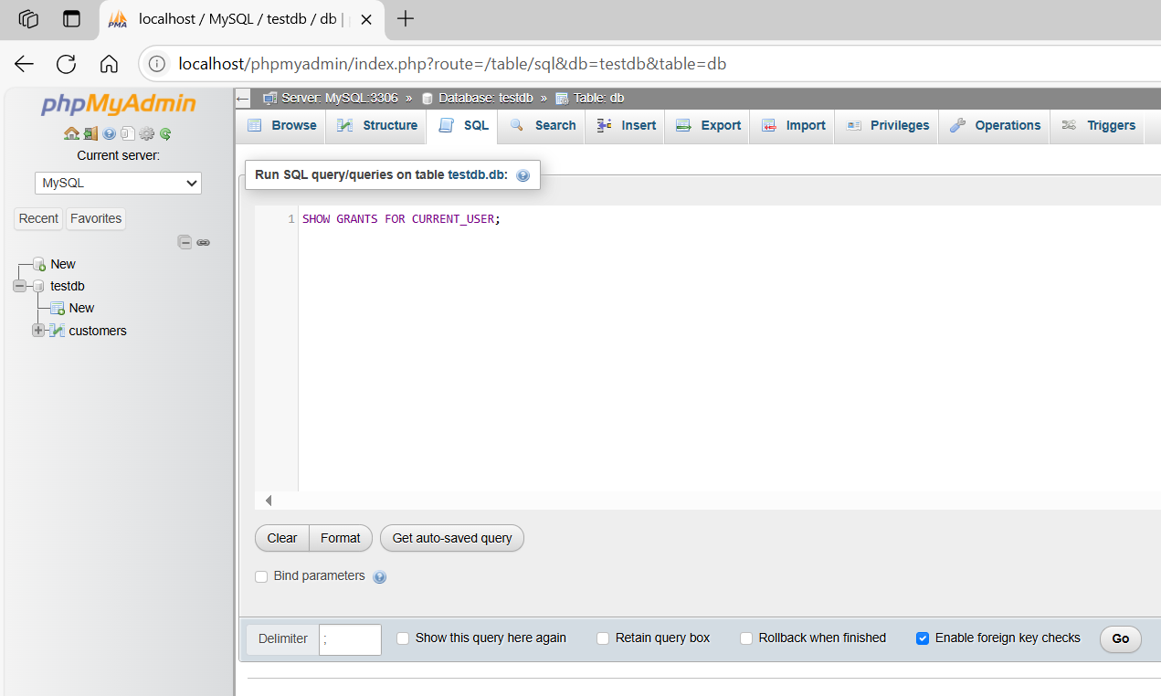
SHOW GRANTS FOR CURRENT_USER;
